Code 1:

%{

#include <stdio.h>

int counter = 0;

%}

%%

[a-zA-Z]+ {

if (yyleng > counter) {

counter = yyleng;

}

}

%%

int yywrap() {

return 1; // Indicate that there are no more input files

}

int main() {

yylex();

printf("largest: %d\n", counter);

return 0;

}

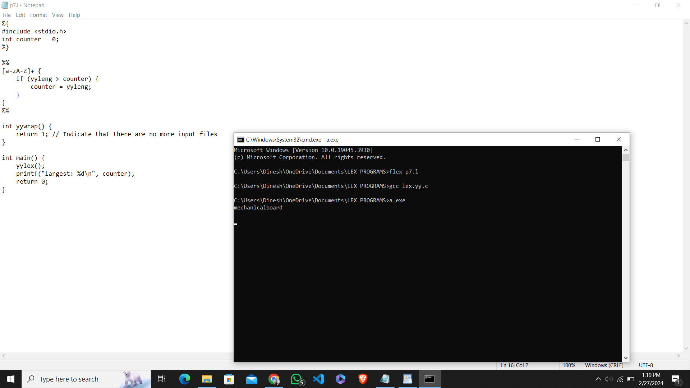

2.CODE

%%

((http)|(ftp))s?:\/\/[a-zA-Z0-9](.[a-z])+(.[a-zA-Z0-9+=?]) {printf("\nURL Valid\n");}

.+ {printf("\nURL Invalid\n");}

%%

void main()

{

printf("\nEnter URL : ");

yylex();

printf("\n");

}

int yywrap()

{

}

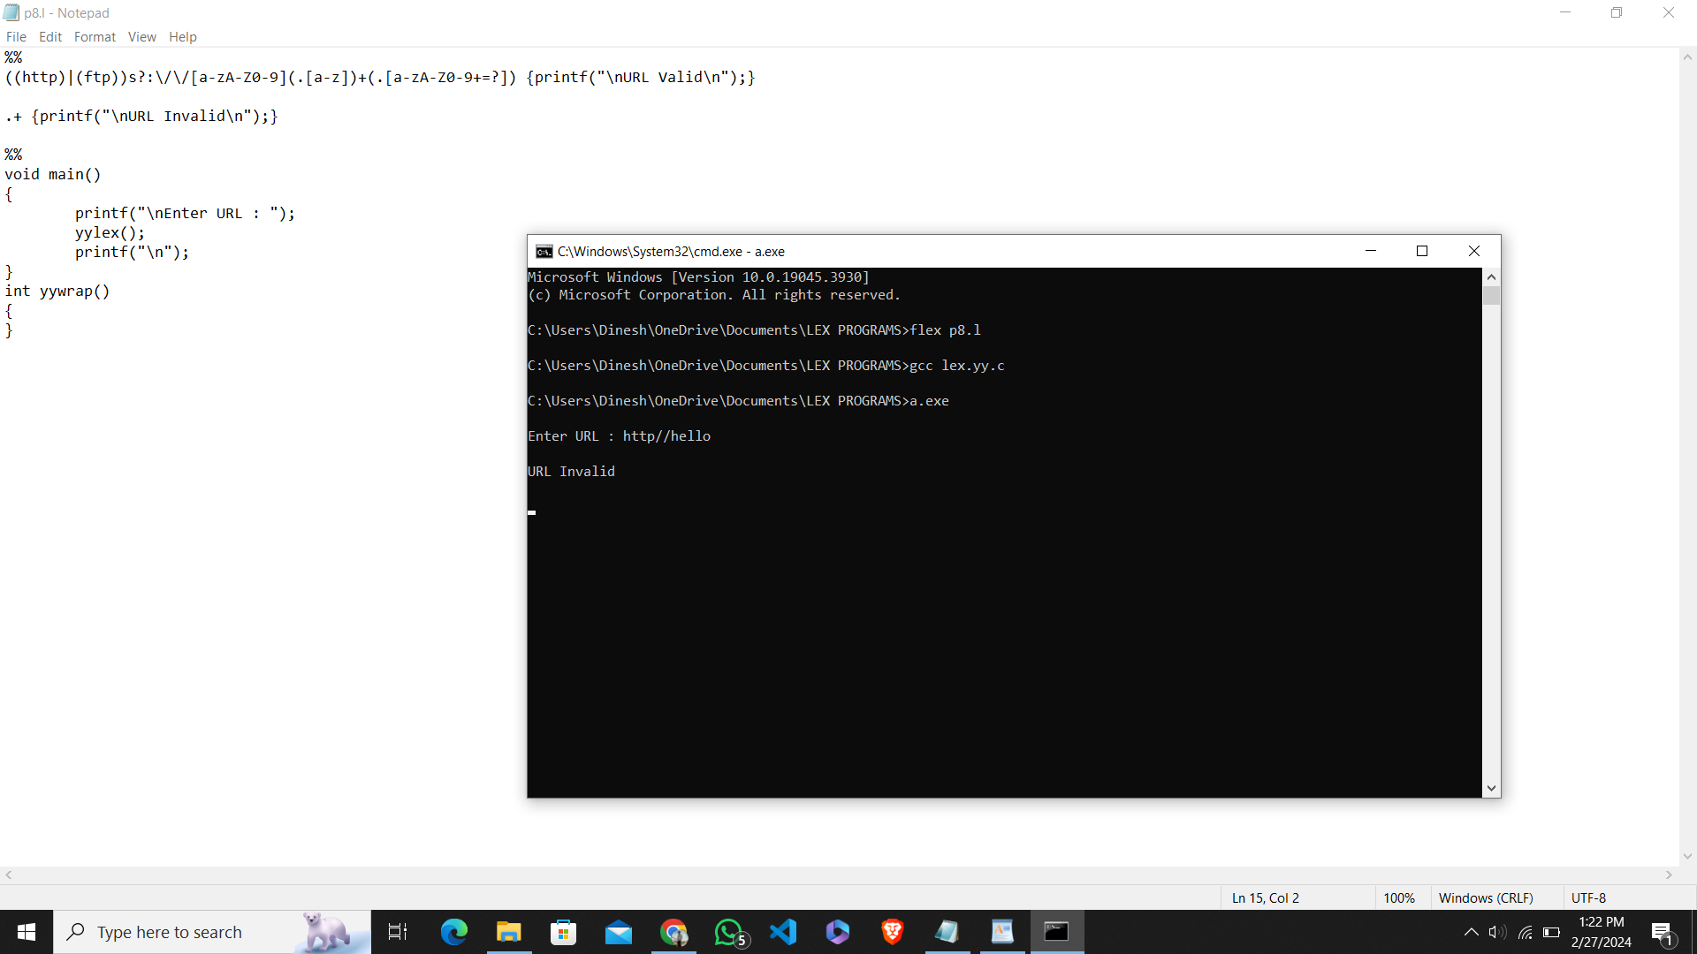

3.CODE

%%

((0[1-9])|([1-2][0-9])|(3[0-1]))\/((0[1-9])|(1[0-2]))\/(19[0-9]{2}|2[0-9]{3}) printf("Valid DoB");

.\* printf("Invalid DoB");

%%

int main()

{

yylex();

return 0;

}

int yywrap()

{}

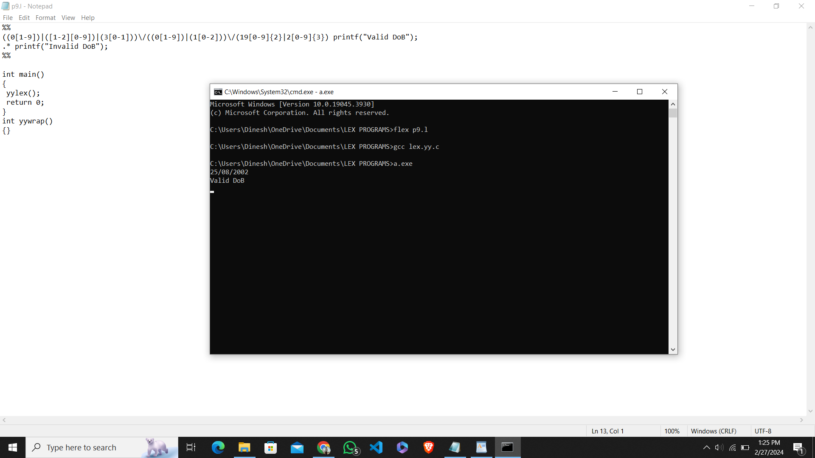

5.CODE

%{

#include <stdio.h>

%}

%%

[a-zA-Z][a-zA-Z0-9]\* { printf("Word: %s\n", yytext); }

"=="|"<"|">"|"<="|">="|"!=" { printf("Relational Operator: %s\n", yytext); }

. ; // Ignore any other characters

%%

int main() {

yylex();

return 0;

}